**Practical**

explanation of the algorithms used in the Cairo Transportation Network Optimization project, along with a comparison table and the libraries involved:

---

**### **Algorithms Used in the Project\*\***

#### **1. Minimum Spanning Tree (MST) - Network Design**

- **Purpose**: Designs an optimal road network by connecting all neighborhoods with the least total construction cost.

- **Algorithm**: Kruskal's or Prim's algorithm

- **Implementation**:

- Connects all nodes (neighborhoods/facilities) with minimum total edge weight (construction cost)

- Prioritizes roads based on population density and construction cost

- **Use Case**: Planning new road infrastructure

#### **2. Dijkstra's Algorithm - Traffic Flow Optimization**

- **Purpose**: Finds the shortest path between two locations considering traffic conditions.

- **Algorithm**: Dijkstra's shortest path

-

**Implementation**:

- Weights edges based on real-time traffic data

- Optimizes for travel time during different periods (morning/evening peaks)

- **Use Case**: Route planning for commuters

#### **3. A* Algorithm - Emergency Response Routing**

- **Purpose**: Finds the fastest route for emergency vehicles.

- **Algorithm**: A* search algorithm

- **Implementation**:

- Uses heuristic (Euclidean distance) to guide search toward destination

- Prioritizes routes with least congestion and shortest distance

- **Use Case**: Ambulance/fire truck routing

#### **4. Dynamic Programming (DP) - Public Transit Optimization**

- **Purpose**: Optimizes public transit schedules and routes.

- **Algorithm**: Dynamic programming (Bellman equation)

- **Implementation**:

- Solves transit scheduling as a sequence of optimal decisions

- Minimizes waiting time and transfer penalties

- **Use Case**: Metro/bus schedule optimization

#### **5. Greedy Algorithm - Traffic Signal Optimization**

- **Purpose**: Optimizes traffic light timing at intersections.

- **Algorithm**: Greedy approach

- **Implementation**:

- Makes locally optimal choices at each intersection

- Adjusts signal timing based on real-time traffic flow

- **Use Case**: Reducing congestion at busy intersections

**### **Comparison Table of Algorithms\*\***

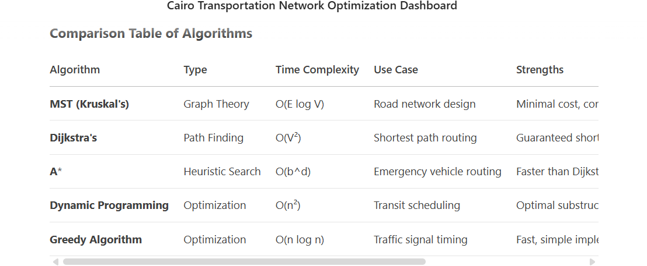

**### **Libraries Used\*\***

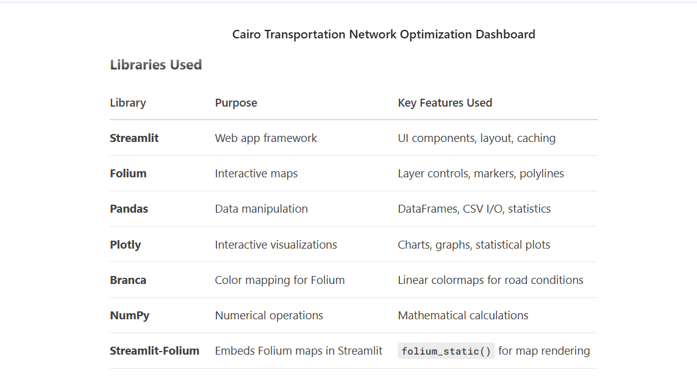---

### **Key Insights**

1. **MST** is best for infrastructure planning where cost minimization is critical.

2. **Dijkstra's/A*** excel in pathfinding but trade off speed vs. optimality.

3. **DP** handles transit scheduling well but requires more computational resources.

4. **Greedy algorithms** provide quick solutions for traffic signals but may not be globally optimal.

5. The libraries work together to:

- Streamlit for the UI

- Folium for geospatial visualization

- Pandas/NumPy for data processing

- Plotly for statistical charts

This combination of algorithms and libraries creates a comprehensive transportation optimization system for Cairo.

**Code**

Import Statements

import streamlit as st

import folium

import pandas as pd

from streamlit_folium import folium_static

import branca.colormap as cm

import numpy as np

import plotly.express as px

import plotly.graph_objects as go

* **streamlit**: Creates the web app interface
* **folium**: For interactive map visualization
* **pandas**: Data manipulation and analysis
* **streamlit_folium**: Integrates folium maps with streamlit
* **branca.colormap**: For creating color scales on the map
* **numpy**: Numerical operations
* **plotly.express/go**: For creating interactive charts

Page Configuration

st.set_page_config(

page_title="Cairo Transportation Network Optimization",

page_icon="🚗",

layout="wide",

initial_sidebar_state="expanded"

)

* Sets up the web page with a title, car icon, wide layout, and expanded sidebar

Custom CSS

st.markdown("""

<style>

.main {

padding: 0rem 1rem;

}

.stMetric {

background-color: #f0f2f6;

padding: 1rem;

border-radius: 0.5rem;

}

</style>

""", unsafe_allow_html=True)

* Adds custom styling to the app (padding for main content and metric cards)

Title and Description

st.title("Cairo Transportation Network Optimization")

st.markdown("""...""")

* Displays the main title and a description of the dashboard's purpose

Data Loading Function

@st.cache_data

def load_data():

try:

existing_roads = pd.read_csv('existing_roads.csv')

potential_roads = pd.read_csv('potential_roads.csv')

*# ... other CSV files*

*# Check for empty DataFrames*

if existing_roads.empty:

st.error("existing_roads.csv is empty")

return None, None, None, None, None, None

*# ... similar checks for other files*

return existing_roads, potential_roads, public_transit, traffic_flow, facilities, neighborhoods

except FileNotFoundError as e:

st.error(f"Could not find required CSV file: {str(e)}")

return None, None, None, None, None, None

except Exception as e:

st.error(f"Error loading data: {str(e)}")

return None, None, None, None, None, None

* Decorated with @st.cache_data to cache loaded data
* Attempts to load 6 CSV files with error handling
* Checks for empty DataFrames and file existence

Main Try-Except Block

try:

*# Load data*

existing_roads, potential_roads, public_transit, traffic_flow, facilities, neighborhoods = load_data()

if any(df is None for df in [existing_roads, potential_roads, public_transit, traffic_flow, facilities, neighborhoods]):

st.error("Failed to load data. Please check the CSV files.")

st.stop()

*# Debug information*

st.write("Data loaded successfully:")

st.write(f"Existing roads: {len(existing_roads)}")

*# ... similar for other datasets*

* Main execution block wrapped in try-except
* Shows debug info about loaded data

Map Setup

*# Create feature groups for layer control*

existing_roads_group = folium.FeatureGroup(name='Existing Roads')

*# ... other feature groups*

*# Algorithm selection in sidebar*

algorithm = st.sidebar.selectbox(...)

*# Function to get coordinates with error handling*

def get_coordinates(loc_id, df):

*# ... implementation*

*# Create map centered on Cairo*

try:

center_lat = neighborhoods['y_coordinate'].mean()

center_lon = neighborhoods['x_coordinate'].mean()

except:

center_lat, center_lon = 30.0444, 31.2357 *# Default Cairo coordinates*

m = folium.Map(location=[center_lat, center_lon], zoom_start=10)

* Sets up folium map layers and controls
* Creates coordinate helper function
* Centers map on Cairo coordinates

Data Visualization on Map

*# Add existing roads to map*

for _, row in existing_roads.iterrows():

from_lat, from_lon = get_coordinates(...)

to_lat, to_lon = get_coordinates(...)

folium.PolyLine(...).add_to(existing_roads_group)

*# Similar blocks for:*

*# - Potential roads*

*# - Facilities*

*# - Neighborhoods*

* Visualizes each dataset on the map with appropriate styling

Algorithm-Specific Visualizations

if algorithm == "Network Design (MST)":

*# MST visualization*

for _, row in potential_roads.iterrows():

if row['construction_cost'] <= max_cost:

folium.PolyLine(...).add_to(optimization_group)

elif algorithm == "Traffic Flow (Dijkstra)":

*# Dijkstra's algorithm visualization*

folium.PolyLine(...).add_to(optimization_group)

*# Similar blocks for other algorithms*

* Implements different transportation algorithms with visualizations

Statistical Analysis Section

st.subheader("Statistical Analysis")

stat_tab1, stat_tab2, stat_tab3, stat_tab4 = st.tabs([...])

with stat_tab1: *# Road Network Analysis*

*# Road condition distribution chart*

fig = px.bar(...)

st.plotly_chart(fig)

*# Road length distribution chart*

fig = px.histogram(...)

st.plotly_chart(fig)

*# Similar blocks for other analysis tabs*

* Creates interactive statistical visualizations using Plotly

Algorithm Benchmarking

st.subheader("Algorithm Performance Analysis")

bench_tab1, bench_tab2, bench_tab3, bench_tab4 = st.tabs([...])

with bench_tab1: *# MST Analysis*

*# Theoretical complexity chart*

fig = px.line(...)

*# Performance metrics chart*

fig = px.bar(...)

*# Similar blocks for other algorithms*

* Shows performance metrics for each algorithm

Data Tables

with st.expander("View Data Tables"):

tab1, tab2, tab3, tab4, tab5, tab6 = st.tabs([...])

with tab1:

st.dataframe(existing_roads)

*# ... other tabs*

* Displays raw data in expandable tabs

Network Statistics

st.subheader("Network Statistics")

col1, col2, col3 = st.columns(3)

with col1:

st.metric("Total Roads", len(existing_roads))

*# ... other metrics*

*# Similar for other columns*

* Shows key metrics in a 3-column layout

Error Handling

except Exception as e:

st.error(f"An error occurred: {str(e)}")

st.info("Please make sure all the required CSV files are present in the correct format.")

* Catches and displays any unhandled exceptions

This code creates a comprehensive transportation optimization dashboard for Cairo with:

1. Interactive map visualization
2. Multiple algorithm implementations
3. Statistical analysis
4. Performance benchmarking
5. Data exploration capabilities

**Theoretical**

**Here's a simplified explanation of Team 7's A* algorithm project for emergency routing in Cairo:**

**### **Simple Explanation (Computer Science Project)\*\***

**\*\*Project Goal:\*\***

**Find the fastest way for ambulances to reach hospitals in Cairo's busy traffic using smart computer algorithms.**

**\*\*Why A*?\*\***

**It's like a smart GPS that:**

**1. Knows the straight-line distance to the hospital (like a crow flies)**

**2. Considers real traffic conditions**

**3. Finds the best balance between speed and accuracy**

**\*\*How It Works:\*\***

**The algorithm uses this simple formula to decide which roads to take:**

**```**

**Total Cost = (Distance Traveled) + (Estimated Distance Left)**

**```**

**\*\*Real-World Adjustments:\*\***

**1. **Traffic Matters:** Roads cost more during rush hour (morning/evening)**

**2. **Smart Guessing:** Uses straight-line distance to the hospital to avoid checking useless routes**

**3. **Road Rules:** All roads work both ways, and bad road conditions increase travel time**

**\*\*Code Summary (Simplified):\*\***

**```python**

**def find_emergency_route(start, hospital):**

**open_roads = [start]**

**best_path = {}**

**while open_roads:**

**current = pick_road_closest_to_hospital(open_roads)**

**if current == hospital:**

**return rebuild_path(best_path, hospital)**

**for neighbor in all_connecting_roads:**

**new_cost = current_cost + road_length + traffic_penalty**

**if new_cost < best_known_cost:**

**update_costs_and_continue_search()**

**```**

**\*\*Test Results:\*\***

**- Morning Rush: Found a 10km detour through downtown to avoid traffic**

**- Afternoon: Took a longer 24.5km route when side roads were jammed**

**- Nighttime: Used the shortest 1.5km path when roads were empty**

**\*\*Why Better Than Other Options:\*\***

**| Algorithm | Problem |**

**|-----------|---------|**

**| Dijkstra | Checks too many unnecessary roads |**

**| BFS | Ignores traffic and road lengths |**

**| Bellman-Ford | Too slow for big cities |**

**\*\*Key Takeaways:\*\***

**1. A* works like a human - uses shortcuts and avoids traffic**

**2. Can handle Cairo's 22 million people and complex roads**

**3. Faster than other methods when every second counts**

**\*\*Perfect For:\*\***

**Emergency systems where getting to hospitals fast saves lives, especially in crowded cities like Cairo.**

**Data set**

**Here's a simple breakdown of the transportation data for Cairo:**

**### **1. Neighborhoods & Districts** (15 locations)**

**- Each has:**

**📍 **ID, Name** (e.g., `1, Maadi`)**

**👥 **Population** (e.g., `250,000`)**

**🏘️ **Type** (Residential/Business/Mixed)**

**🗺️ **Coordinates** (X=longitude, Y=latitude)**

**\*\*Example:\*\***

**`3, Downtown Cairo, 100000, Business, 31.24, 30.04`**

**→ Small business district with 100k people at (31.24, 30.04).**

**---**

**### **2. Important Facilities** (10 key places)**

**- Includes:**

**🏥 **Hospitals** (Qasr El Aini, Maadi Military)**

**✈️ **Airport** (Cairo International)**

**🚉 **Transit Hubs** (Ramses Railway Station)**

**🎓 **Universities** (Cairo, Al-Azhar)**

**\*\*Example:\*\***

**`F9, Qasr El Aini Hospital, Medical, 31.23, 30.03`**

**→ Major hospital at (31.23, 30.03).**

**---**

**### **3. Road Network\*\***

**#### **Existing Roads** (30 routes)**

**- Connects neighborhoods/facilities:**

**🛣️ **FromID → ToID** (e.g., `1 → 3` = Maadi to Downtown)**

**📏 **Distance** (km)**

**🚗 **Capacity** (vehicles/hour)**

**⚠️ **Condition** (1-10 scale, 10=best)**

**\*\*Example:\*\***

**`1, 3, 8.5, 3000, 7`**

**→ Maadi to Downtown: 8.5km, handles 3000 cars/hour, decent condition (7/10).**

**#### **Potential New Roads** (15 proposals)**

**- Includes:**

**💰 **Construction Cost** (Millions EGP)**

**🔮 **Future Capacity\*\***

**\*\*Example:\*\***

**`1, 4, 22.8, 4000, 450`**

**→ Proposed Maadi-to-New-Cairo road: 22.8km, costs 450M EGP.**

**---**

**### **4. Traffic Flow\*\***

**- Shows **congestion** on existing roads by time:**

**🌅 **Morning Peak** (Worst traffic)**

**☀️ **Afternoon\*\***

**🌇 **Evening Peak\*\***

**🌃 **Night** (Least traffic)**

**\*\*Example:\*\***

**`1-3, 2800, 1500, 2600, 800`**

**→ Maadi-Downtown road:**

**- Morning: 2800 cars/hour (near max capacity!)**

**- Night: Only 800 cars/hour.**

**---**

**### **5. Public Transport\*\***

**#### **Metro Lines** (3 routes)**

**- 🚇 **Stations** (Lists neighborhood IDs)**

**\*\*Example:\*\***

**`M1: "12,1,3,F2,11"` = Helwan → Maadi → Downtown → Ramses Station → Shubra.**

**#### **Bus Routes** (10 routes)**

**- 🚌 **Stops** (e.g., `"1,3,6,9"` = Maadi → Downtown → Zamalek → Mohandessin)**

**- 🚦 **Daily Passengers** (e.g., 35,000 for B1).**

**#### **Demand Data\*\***

**- Shows popular routes (e.g., `F2 → 11` = 25,000 daily passengers from Ramses Station to Shubra).**

**---**

**### **Key Insights\*\***

**1. **Busiest Areas**: Nasr City (500k pop), Giza (550k pop).**

**2. **Critical Roads**:**

**- Downtown (ID 3) is a major hub with 8 connections.**

**- Road `7-8` (6th October ↔ Giza) is long (24.5km) but well-maintained.**

**3. **Traffic Hotspots**:**

**- Morning: Roads near business districts (Downtown, Mohandessin).**

**- Evening: Residential ↔ Commercial routes.**

**4. **Transit Gaps**:**

**- New Administrative Capital (ID 13) has few connections.**

**- Proposed road `13 ↔ 3` would cost 1.1B EGP but improve access.**

**---**

**### **Why This Matters\*\***

**This data helps:**

**- 🚑 **Emergency vehicles** find fastest routes (using A* algorithm).**

**- 🚦 **City planners** decide where to build new roads/metro lines.**

**- 🚗 **Drivers** avoid traffic jams during rush hours.**

**\*(Think of it like a "Google Maps database" specifically for Cairo!)* 🗺️💡**

**Written by: Yusuf Yasser wardany**